2022 First Saturday Artist Application
*Required information

*Name: _______________________________________________________________________
Business Name: ________________________________________________________________
*Address: _____________________________________________________________________
*City-State-Zip: ________________________________________________________________
*Home Phone: ________________________ Cell Phone: _______________________________
*Email: _______________________________________________________________________
Website/Facebook: ______________________________________________________________

Emergency Contact Person

*Name: ________________________________________________________________________
*Phone: ___________________________ Relationship: _________________________________

*Describe your artwork (briefly)
We require 4-5 pictures of artwork to complete your application:
___________________________________________________________________________________
___________________________________________________________________________________
___________________________________________________________________________________
___________________________________________________________________________________
___________________________________________________________________________________
___________________________________________________________________________________
___________________________________________________________________________________
___________________________________________________________________________________
___________________________________________________________________________________
___________________________________________________________________________________
___________________________________________________________________________________
___________________________________________________________________________________
By filling out this information you are giving The Chicken Farm Art Center permission to contact you, use photos or information in the process of advertising, informing, and placement for First Saturday events, and to share your information with possible customers or interested parties.
Filling out this application does not guarantee acceptance into our event.

First Saturday Policies
Mission Statement
This event was created to share with the community new and established artists, to educate the public about different styles and artistic mediums, and to garner interest in art; encouraging artists to live and work doing what they love. In our mission to encourage art and artists, proceeds made from this event go to a scholarship fund for art students at Angelo State University here in San Angelo, Texas and general costs for hosting this event monthly.
How do we define art?
We view art both in the traditional sense and in its modern interpretations. Painting, printmaking, drawing, pottery, and sculpture are highly encouraged during this event. The unusual or unexpected application of skill and craftsmanship resulting in complete and finished works will also be considered for showing.
What is acceptable for showing?
To encourage what we define as art to be shown during the First Saturday event there are some non-applicable items, themes, and “craft store” type pieces that we do not allow. Sales of commercial products, imports, and manufactured goods are not supported or allowed during this event; such as techniques like sublimation.
We allow select craft vendors. If there is an element of what we consider to be art applied, craft pieces may be considered for showing.
What we define as art will always be given priority during this event.
First Saturdays are family friendly events; we do not allow nudity or risqué types of art to be shown outside of permanent studios.
The Chicken Farm Art Center reserves the right to approve or disapprove of items shown before and during participation in our event.
Food Vendor
If you are applying and plan to sell food items you are responsible for your own licensing and paperwork in accordance with city and state regulations. Please visit https://dshs.texas.gov/foodestablishments/ or call our local city offices to make sure you are up to date for any and all licenses.
It is the responsibility of the vendor to keep all paperwork on hand for city inspection, we are not responsible for keeping documentation of this sort on hand.
We do not guarantee or provide electricity for events, vendors are responsible for their own energy sources.
How to Apply
Interested artists/vendors must apply for First Saturday at our office, located at 2505 Martin Luther King, San Angelo, TX 76903 or calling 325-653-4936 and speaking with one of our team members.
Prospective artists and craftsmen must fill out the Artist Information Application and submit 4-5 photos of their work for review to be considered for the event. Artist Resumes are optional, but strongly encouraged. Our office will review applications in accordance with the previous requirements stated (See How do we define art? and What is acceptable for showing?) and will contact the applicant with our decision. You can email images of your work to chickenfarmartcenter@gmail.com.

Booths, Fees, and Policies
Booth rental fees are $15-$30 for the day, depending on the location; tables are available for $5 each. All fees are non-refundable. All vendor spaces are outside. Most spaces will accommodate an 10x10 tent or smaller (actual space 10x10); contact our office for location information. Artists/Vendors are responsible for setting up their own tent and space, cleaning up their vendor space, and putting away any equipment they might have used for the event!
There are four locations along the back parking lot, which will be given at a reduced rate of $15 for the day. Requests for these locations will be on a first come, first serve basis. Meaning that you need to request at the time of your confirmation for one of these locations and we will adjust your fee appropriately.
All contact is made via email. We send out a Vendor Roll Call on the 10th of the month. Artists/vendors must reply confirming attendance for the upcoming First Saturday. The deadline for contact is by 5pm on the 25th, after which any locations being held tentatively will be made available to any artists/vendors on the waiting list.
Payment will be accepted in the form of CASH or CHECK only. Checks must be made out to The Chicken Farm Art Center, or CFAC LLC. Payments must be made by the 25th before 5pm. If you are not able to make the payment by this date and still wish to attend, our office must be contacted for considerations to be made. We allow spaces to be paid for in advance.
Booth spaces are distributed on a first come, first serve basis and are subject to rotation pending themed weekends, reorganization, or special needs. We do not guarantee locations, or that they will be the same every time.
If you are unable to attend, please notify us prior to First Saturday so that we may fill your vendor space with another artist. Failure to do so will be a violation against you.
First Saturdays run from 10am – 5pm and all Artists/Vendors are required to stay for the duration of the event. If there is an emergency and you need to leave sooner, please contact our event coordinator so that arrangements can be made. Leaving without notification (either let Patrick, or someone in the Starkeeper Gallery) will result in a violation.
Early set up is offered the Friday before the event from 2-5pm. Artists/Vendors are welcome to come locate their space and set up their tent and/or tables. The Chicken Farm Art Center is not responsible for any items left here overnight. Set up on Saturday morning starts at 8am. The event starts at 10am, be ready by 9:30.
All vehicles must be parked off the property or across the street by 9:30am and are not permitted back on the premises till after 5pm.
No early take downs. Exceptions will be considered in case of an emergency.
Demonstrations are allowed. If they are loud please notify us so that we can place you away from the music. If it will be messy, notify us so that we can put you in an appropriate location for easy cleanup after the event.
Smoking outside is permitted during this event in accordance with city ordinances. No smoking within 15 feet of public entrances. We have ashtrays located around The Art Center for your convenience. If you wish to smoke at your booth, please talk to the artists/vendors around you to be sure that they are comfortable with that. Do not leave your butts on the ground. Please keep a butt can handy and dispose of it properly at the end of the event.
Violations
To maintain the quality of art and atmosphere that we strive for during our events, if an Artist/Vendor violates one of the rules for First Saturday there are consequences. In this order the following will be given: a series of email warnings following the violation/event (maximum of 3), once the third violation has been recorded any further violations will require a review from the committee and could result in relocation, restrictions, or removal from showing at First Saturdays.
While we do not wish to do this, our mission and the expectations of the public must be upheld to the best of our ability. So long as there is open and honest communication between all artists, vendors, and our office all issues can be resolved.

I, ___________________________, (print name) have completely read and agree to these terms and conditions. I understand that by signing this form I am bound to the rules and regulations set by The Chicken Farm Art Center hosting this and all art events. I verify that all information supplied on my application is current and accurate. I understand that this is an application and does not warrant acceptance to show during First Saturday and that if approved I will be contacted by The Chicken Farm Art Center and notified accordingly.

Date: ____________________________________________________________________
Signed: __________________________________________________________________

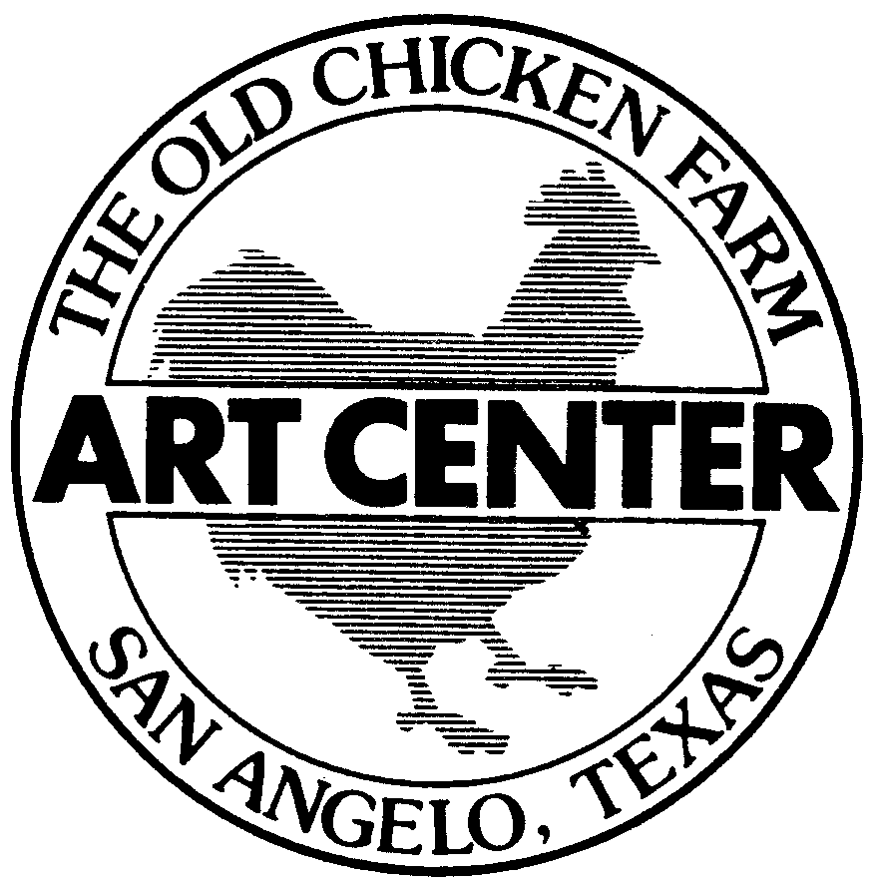

The Chicken Farm Art Center
2505 Martin Luther King
San Angelo, TX 76903
Phone: 325-653-4936
Email: chickenfarmartcenter@gmail.com

